How to write an article for peer-reviewed scientific proceedings presented onto International acoustic conference in Kocovce
Radoslav Darula, Ing. PhD.— Stanislav Žiaran, prof. Ing. PhD.
Faculty of Mechanical Engineering, Slovak University of Technology in Bratislava
e-mail: radoslav.darula@stuba.sk; stanislav.ziaran@stuba.sk
Introduction
The template is prepared for participants of annual International Acoustical Conference in Kocovce to unify the documents. Please use for writing of the paper MS Word.
The contribution should be submitted in two formats – in MS Word as well as in pdf version (using e.g. Adobe free online convertor [9], or PdfFactory [11])
The A4 page is used with borders 2.7 mm from the top, 2.8 mm from bottom and 2.5 mm from left and right. In the first page place for heading (9.5 mm from top) is necessary to be keep free, if is not used this template. Whole page formatting and the preliminary heading have already been prepared into this template, so feel free to modify it and use it as a basic document for your contribution.
Maximal size of the paper is 4 or 6 pages (pictures and tables included). The even number of pages is required.
Pages are not numbered! The numbering is done afterwards by an editor.
The contributions are written in Slovak, Czech or English language.
If possible, use styles defined in this template, e.g. just rewrite the title, names of authors, occupation, main text and references. Please follow instructions summed up in the template. If you have any questions, feel free to contact any of the authors of this template. The e-mail addresses are listed in the heading.
Title/Authors/Affiliation
Writing the paper heading, please follow the rules listed below:
- Title is written in bold, Arial 14pt. No Capital letters used;
- The names of authors are written in bold, Arial 12pt. Spacing from the top is 12 pt. First write the first name, then surname ended with comma, and afterwards put corresponding title(s). If more authors are contributing, use dash between names. If more than 3 authors are writing the paper, use just first letter of first name to save some space, e.g.:
Radoslav DARULA, Ing. PhD.— Stanislav ŽIARAN, prof. Ing. PhD. — …
- The affiliation of the authors is written on a new line, in Arial 12pt. State also the town, in which the university/company/organization is located, for non-Slovak/Czech towns state also the country. If two or more authors have two or more affiliations, use markers to distinguish which author corresponds to which affiliation, e.g.:
Radoslav Darula, Ing. PhD. *— Stanislav Žiaran, prof. Ing. PhD.**
*Institute of Mechanical Engineering, Aalborg University, Denmark
**Faculty of Mechanical Engineering, Slovak University of Technology in Bratislava

- The e-mail of at least one of contributors is written on a new line after the ‘e-mail’ label:
e-mail: stanislav.ziaran@stuba.sk
Writing style of sections/subsections
The section names are written with bolded Arial, 14 pt, with space before 6 pt. and after 3 pt. Headings are not numbered! and aligned to the left. No indentation used.
Text in section are written with Arial, 12 pt. Indentation of each paragraph is 1 cm. Spacing is set to 1.
In writing the sections try to avoid:
- Leaving heading at the bottom of the page (new section cannot start at the new page with no heading);
- When writing numbers and units, avoid have number on one line and unit on another, e.g. 5
mm…instead use ‘tight space’ [ctrl+shift+space] – e.g. 5 mm;
- Writing section numbers – chapters/sections are not numbered;
Writing equations
The equations are indented 1 cm (as the paragraphs are) and are numbered with a number enclosed in parenthesis and aligned to the right. Use upper and bottom spacing of 6 pt:
(1)
To write the equations, it is recommended to use directly Microsoft Equation Editor. In the text please use referencing as e.g. ‚...shown in equation (1)...‘.
Figures
The best option is to use grayscale figures, as the proceeding is not printed in colour. All the figures are needed to be placed in the text together with their captions. If the figure is small, it can be put into a table, with the caption on the right (Fig. 1), in order to save some space. Then the caption is centred to the left. Use Arial, 10, bold.
 | Figure 1 – Text of figure, Arial, 10, bold, can be used caption to hyperlink labels.
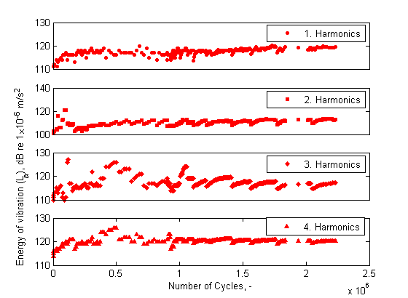  (a) |  | 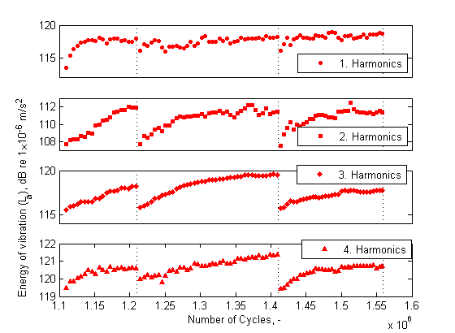  (b)
Figure 2 – For caption use Arial, 10 pt, centred, 6pt space after the caption.
Otherwise, for large figures, the caption is centred, with space after 6 pt, 0 pt before. If you want to use two figures, you can put it into the table with labelling (a) and (b), as shown in Figure 2a and 2b.
Some rules for inserting the figures:
- If possible use figures in .jpg, .gif, .bmp, .tif or figures created in Word/Excel/ PowerPoint. If converting to .jpg or other formats please choose resolution at least 300 dpi (if possible);
- It is best to have figures in black and white or use grayscale. Plotting graphs please vary thickness and line-style to distinguish variable options, not colour;
- If some plots from e.g. Excel are used as a figure, use ‘Edit -> Paste Special -> Picture(Enhanced Metafile)’ in order to avoid linking the figure to Excel spreadsheet. Otherwise problems with correct visualization can occur;
- Ensure that the figures are clear, easy to understand and labels are readable.
Tables
Writing a table, use Arial, 10, for the first line bold. No table border is used, only the first and last line is 1.5b. and the second 0.75b. Table is centred, so caption is. Caption is similar as in figure, i.e. use Arial, 10, bold. Table caption is put above the table. Use 6pt spacing before and 3pt after the table caption.
How to cite a publication in the text?
The list of references is presented at the end of the paper. Each item is labelled by a number in square brackets.
For citation within the document, you can use hyperlinks, i.e. use ‘Insert
->Cross Reference->Numbered Item’ and from the list choose the item of document to be cited. Then choose ‘Item number’ and insert into the text.
Conclusion
If you have any comments or doubts, feel free to contact the organizer. The e-mail addresses are listed in the first page.
References
  - Crocker, M. J.: Encyclopaedia of Acoustics. John Wiley & Sons. New York, 1997
  - Ziaran S. Effects of low-frequency noise in closed space on the human. In: InterNoise 2011 Osaka/Japan.
  - Žiaran, S.: Potential Health Effects of Standing Waves Generated by Low Frequency Noise. Journal Noise and Health. July-August 2013, Volume 15:65, 237-45, ISNN 1463-1741.
  - B&K: Data sheet DeltaTron® Accelerometer Types 4514-001. Brüel & Kjær, Nærum, 2006
  - Ziaran S. Low Frequency Noise and Vibration. Monograph, Issued by STU Bratislava 2016; pp.316.
  - STN ISO 1996-1:2006: Akustika. Opis, meranie a posudzovanie hluku vo vonkajšom prostredí. Časť 1.: Základné veličiny a postupy posudzovania.
  - Anon.: web stránka Slovenskej Technickej Univerzity, posledný prístup v marci 2010: www.stuba.sk
Resumé
International acoustic conference in Kocovce. In the articles written in English, the resume should be written in Slovak or Czech language and for participants from other countries, besides SK and CZ, in English. The name of the contribution should be written in bold as the first sentence of the paragraph. No indentation used. Then start to write the short resume, using font Arial 10.
Acknowledgement
At the end of the article, you can thank to your colleagues for the help in the work, or grant agency for supporting the project financially.

